Job Description: Post-Doctoral Research Fellow

Institute/Department | UCL Institute of Prion Diseases
Grade | UCL Grade 7
Salary per annum | £39,508 (including London allowance)
Reporting to | Dr Szymon W. Manka
Duration | 4-year fixed term contract
Hours of work | 36.5 hours per week (1.0 FTE)
Annual leave | 27 days per annum pro rata
Location | London W1W 7FF
Probation period | 9 months

About the Institute of Prion Diseases

The Institute of Prion Diseases is part of the Faculty of Brain Sciences, School of Life and Medical Sciences (SLMS), at UCL. The Institute incorporates the Medical Research Council (MRC) Prion Unit which is an internationally renowned research centre for prion and other degenerative conditions of the brain, including Alzheimer’s disease. It provides a national centre of expertise and training in its field.

The MRC Prion Unit has undertaken ground-breaking research published in the highest quality research journals and its research programmes are highly multidisciplinary and focus both on areas of public health concern and a long-term approach to the understanding of prion disease. They include studies of molecular structure, genetics, biochemistry, immunology, cell and animal models, and clinical research - including treatment trials. Major programmes to develop novel therapies are underway.
The research philosophy is to seamlessly combine basic (laboratory) and clinical (patient-based) research. Efficient translation of these basic studies to enable better early diagnosis, prevention, and effective treatments, is crucial. A UK-wide tertiary NHS referral service for patients suspected to have, or at risk of developing, any form of prion disease - the National Prion Clinic (NPC) - is based at the National Hospital for Neurology and Neurosurgery and is closely integrated with the Institute and led by Unit clinical staff.
The Institute provides a key training resource and centre of specialist expertise in this unique area of biology and medicine and supports the development of neurodegenerative disease research more widely. The team has many local, national, European and other international links and collaborations in prion and other neurodegenerative disease research, and provides an authoritative independent source of advice and opinion in what continues to be an area of major scientific, public health, animal health, political and economic importance.
The Institute is based in the newly refurbished UCL Courtauld Building in Fitzrovia, a vibrant and exciting area of central London, with excellent transport connections and local cultural and social amenities

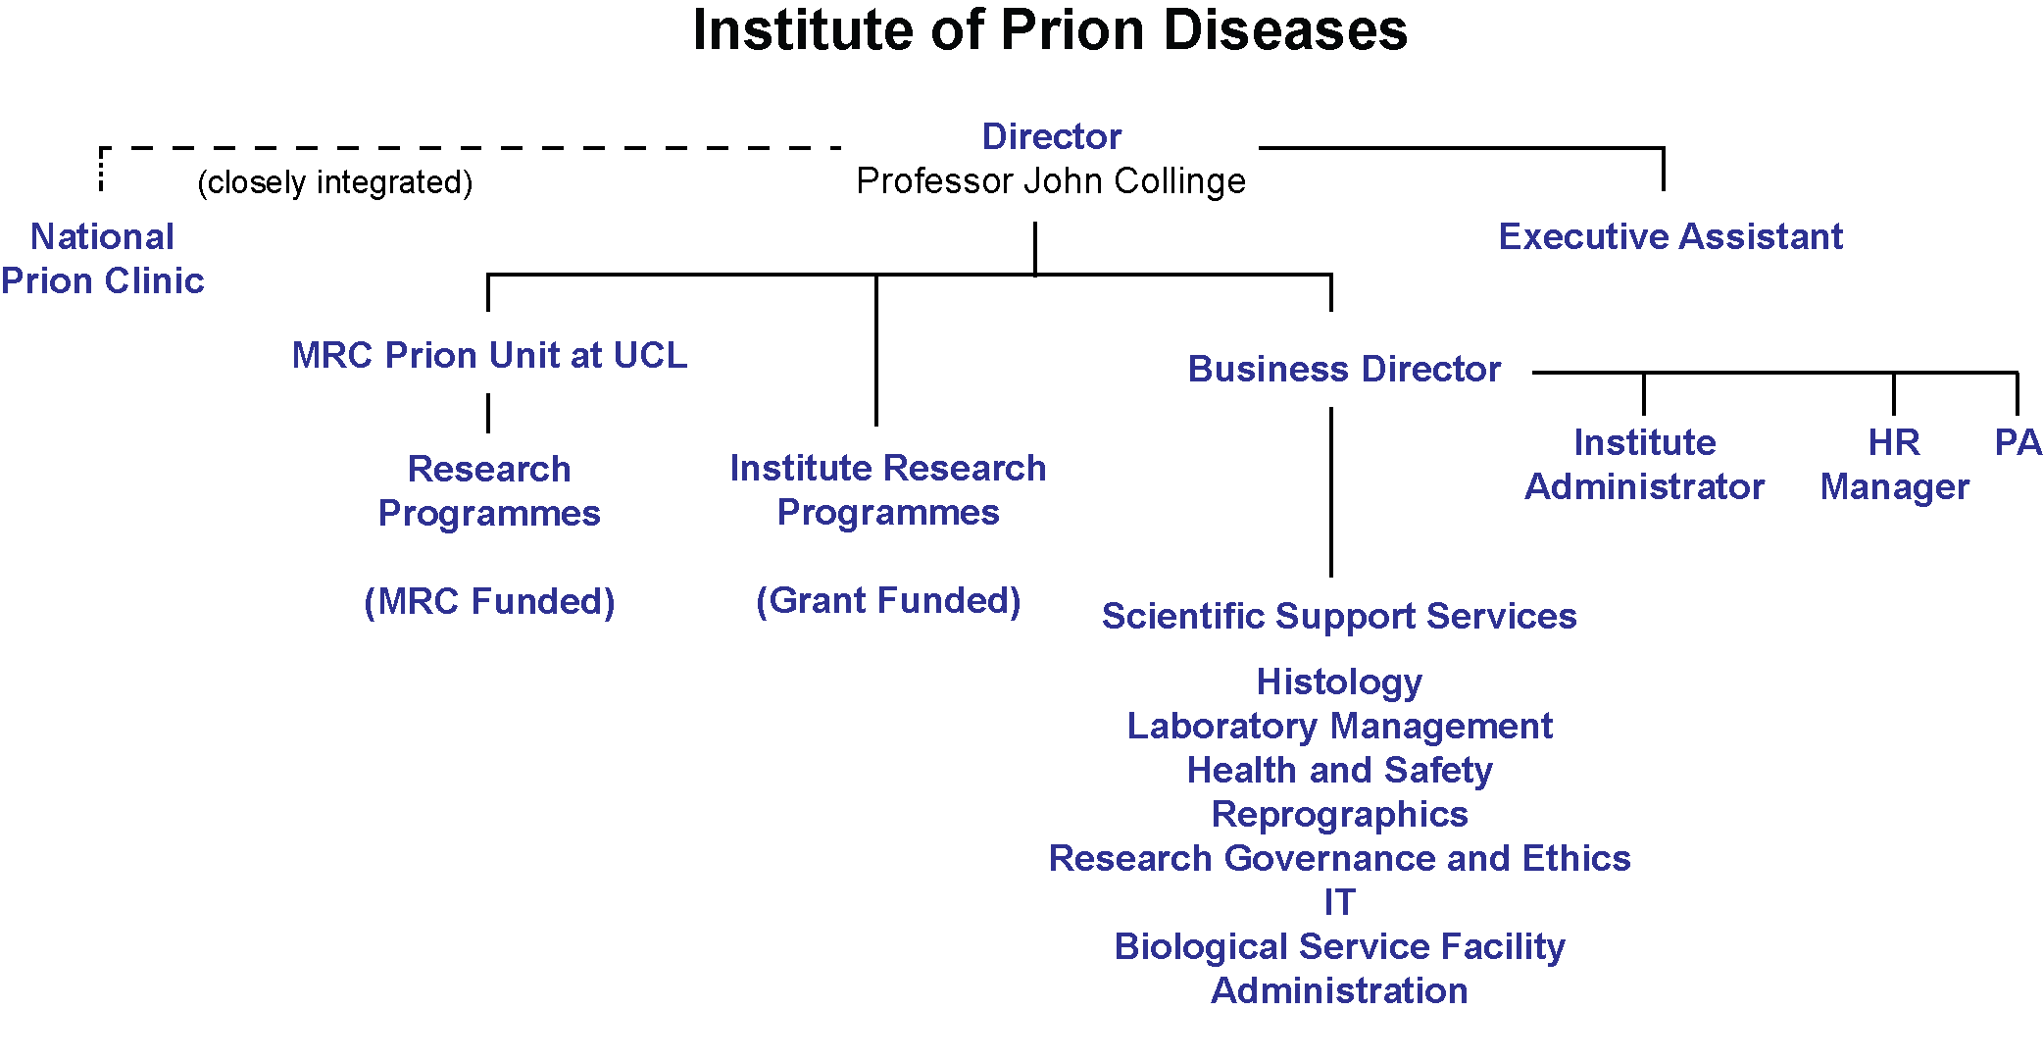
Institute Operational Structure:

Context

The post-holder will be recruited to a grant funded research fellowship programme led by Dr Szymon W. Manka. The objectives of the project are to track fluorescent prion assemblies (F-prions) in cells and tissues by cryo-correlative light and electron microscopy (cryo-CLEM) and to elucidate the in cellulo and in situ structures of prions by cryo-electron tomography (cryo-ET) and sub-tomogram averaging, and structures of purified prions decorated with their binding partners using single particle (SPA) cryo-EM. The post is funded by the MRC Career Development Award to Dr Manka.

This is an entry level position for a PhD awarded candidate. We are looking for a highly motivated and enthusiastic individual who will thrive in a laboratory with a friendly and supportive atmosphere. The successful candidate should have a PhD in structural biology, cell biology, biochemistry, molecular biology or a relevant subject area, and experience in cryo-ET data processing and structure determination by sub-tomogram averaging. The candidate should be able to work independently and have good communication skills to work in a team.

Role

The objectives of the post are to:
- lead the study of prion assemblies in cells and tissue sections using cryo-CLEM and cryo-ET;
- conduct collaborative research, process data, analyse, interpret and discuss results;
- solve 3D protein structures by sub-tomogram averaging and SPA;
- write manuscripts and create figures for scientific publications;
- provide support and training to junior members of the group.

Duties and responsibilities

- Characterisation of prion assemblies in prion-infected cell cultures and mouse brain sections by cryo-EM/CLEM/ET will require extensive collaborations, with members of the Manka group, other colleagues from the IoPD and other collaborating institutions. This may include traveling and performing experiments in other cities within the UK and Europe.
- Effective and productive interaction, especially with external collaborators, will be required to facilitate optimal distribution of tasks and to develop effective research pipelines
- Participation in designing and carrying out wet lab experiments, including, but not limited to genetic modification of cells, protein purification, cell/tissue culture maintenance and sample preparation for cryo-EM/CLEM/ET.
- Determination of high-resolution 3D cryo-EM/ET maps of prion assemblies (+/- binding proteins) using modern software for sub-tomogram averaging analyses, SPA and potentially custom scripts, followed by atomic model building and validation where required.
- Performing other microscopy techniques, including various modalities of fluorescence microscopy or atomic force microscopy may also be required.
- Presenting the research findings at internal and external meetings and scientific conferences
- Preparation and formatting of data for scientific publications, including statistical analyses, and drafting of scientific papers.
- Assistance with the supervision and intellectual and practical support of students and other colleagues within the research programme.
- Ready sharing of tools, strategies, computer scripts and all sorts of methodological inventions within the research group to maximise the group’s productivity and scientific output.

Professional and Quality Standards

The post holder will be responsible for organising their own work and encouraged to run their research as independently as possible. Regular meetings with the group leader will ensure that guidance is always provided as and when needed. The research project in question is highly interdisciplinary and collaborative, thus recognition of and consideration for shared study objectives will be expected. The post holder will also keep abreast of the relevant literature and translate knowledge of advances into research activity.

General

As duties and responsibilities change, the job description will be reviewed and amended in consultation with the post holder.

The post holder will carry out any other duties as are within the scope, spirit and purpose of the job as requested by the line manager. The staff member has a responsibility to carry out their duties in a way that embodies UCL’s environmental and social sustainability values, actively supporting UCL’s Sustainability Strategy, policies and objectives within the remit of their role.

The successful candidate will need to meet UCL’s expectations of core behaviours, as outlined in http://www.ucl.ac.uk/hr/od/core-behaviours/index.php

The post holder will actively follow UCL policies including Equal opportunities and Race Equality policies

Person Specification

 | Essential or Desirable | Assessment method  (Application/Interview)
Qualifications, experience and knowledge
PhD in structural biology, biochemistry, molecular biology, cell biology or another relevant subject area | E | A
Skills and abilities
Experience with cryo-EM/ET, tomogram segmentation, sub-tomogram averaging, 3D structure determination | E | A/I
Evidence of publishing high-quality work | E | A/I
Experience with aseptic cell/tissue culture | D | A/I
Experience with fluorescence or correlative microscopy | D | A/I
Established skillset in molecular biology and protein biochemistry | D | A/I
Experience in performing biophysical assays | D | A/I
Experience in genetic code expansion and bio-orthogonal labeling | D | A/I
Experience in protein mutagenesis and purification | D | A/I
Experience in neurodegenerative diseases research | D | A/I
Programming skills (Python, MATLAB, etc.) | D | A/I
Excellent working knowledge of data analysis and graphing | D | A/I
Scientific writing and figure preparation skills | D | A/I
Personal attributes
Adaptable and flexible with an ability to grasp new skills quickly | E | A/I
Enthusiastic, self-motivated, driven | E | A/I
Working well within a team | E | A/I
Excellent communication and writing skills | D | A/I
Able to work independently | D | A/I

Appointment Details

The post is available from 1 November 2023. The post will be offered subject to satisfactory references, security clearance and successful completion of a 9-month probationary period. The post is available on a 4-year fixed term contract in the first instance.

Salary

The post is graded as Grade 7 and will be offered on a salary of £39,508. Progression through the salary scale, which ranges from £39,508 - £47,355 is incremental. Cost of living pay awards are negotiated nationally and are normally effective from 1st August each year.

Probation

Appointments are subject to receipt of satisfactory references and a probationary period of 9 months.

Hours of work

Full time 36.5 hours per week and times of work are as determined by the line manager.

Annual leave

Annual leave is 27 working days for a full-time member of staff + 6 UCL closure days in addition to 8 Bank Holidays.

Pension

Appointments are superannuable under the Universities Superannuation Scheme (USS) or, subject to eligibility requirements, the National Health Service Pension Scheme (NHSPS). Further information about USS and the benefits can be found at www.uss.co.uk.

Season ticket loans

A season ticket loan is available to staff with the facility to repay through a monthly deduction from salary.

Other benefits

Other benefits of joining UCL as a staff member are many and include:
- Access to an extensive range of in-house staff development opportunities. Staff have full use of the UCL libraries and UCL operates a Study Assistance Scheme for those undertaking part-time work-related study.
- An excellent location for transport networks being near Euston, King’s Cross and St. Pancras stations and a choice of underground stations connected to London's other mainline stations. A wide range of bus routes serves the area.
- UCL lies in Bloomsbury, just north of Oxford Street, Covent Garden and the heart of the West End with access to shops, theatres, cinemas, bars and restaurants. UCL also has its own 550 seat West End arts venue (Bloomsbury Theatre) which hosts drama, dance, music, debates and lectures during the year.
- The main campus has subsidized cafeterias/bars and shops, gym and a travel agent. UCL staff can also benefit from corporate membership at a Tottenham Court Road gym.

Applications

You should apply for this post through UCL's online recruitment – www.ucl.ac.uk/hr/jobs where you can download a job description and person specification.
If you have any queries regarding the application process, please contact HR Manager, Amali De Silva; AmaliDeSilva@prion.ucl.ac.uk

