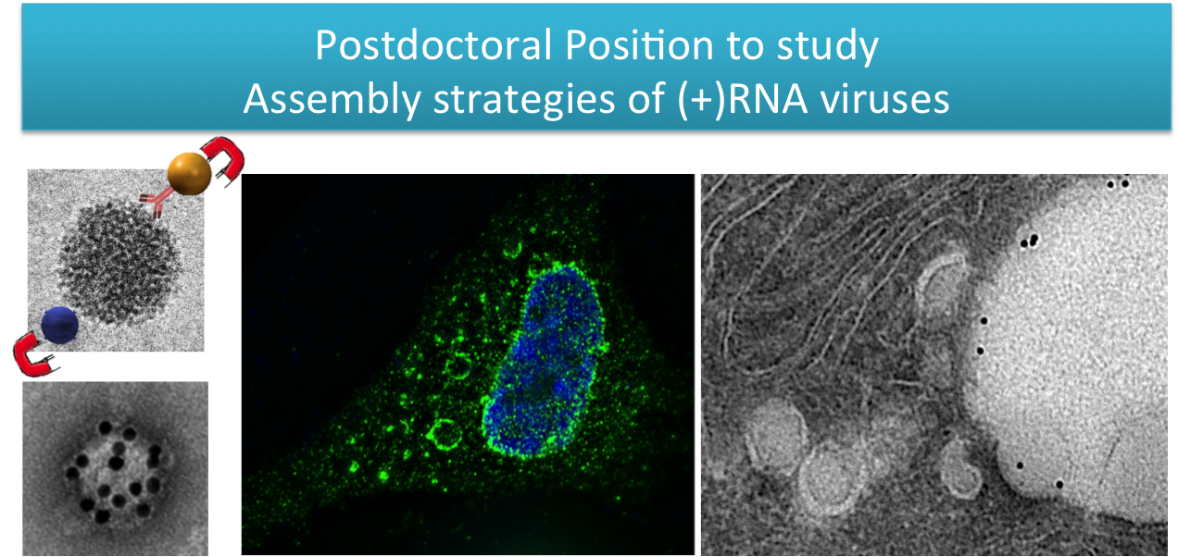

A postdoctoral position is available in the laboratory of Dr. Maria Teresa Catanese, at King’s College London. The project for this position focuses on the study of virus-associated host factors and their role in the assembly of positive-strand (+)RNA viruses (Catanese et al, PNAS 2013; Lussignol et al, PNAS 2016). The successful candidate will be comparing and contrasting the exploitation strategies of cellular factors developed by the Flaviviridae Zika virus, dengue virus and hepatitis C virus, with a particular focus on the process of endomembrane remodeling in relationship to virion morphogenesis. The project will combine molecular virology, cell biology and biochemistry with state-of-the-art live cell imaging, super resolution and electron microscopy.
For enquiries please contact maria.catanese@kcl.ac.uk

Project Start Date: 01 Aug 2016
Initial duration of contract: 1 Year
Salary: between £32,600 - £36,672 (depending on experience) + London Allowance: £2,323
Applications close by 1st July

Host cell factors regulating the assembly of positive-strand RNA viruses

Background. Positive-strand (+)RNA viruses are the largest group of RNA viruses and include the Flaviviridae (hepatitis C virus; dengue virus; Zika virus), Togaviridae (Sindbis virus; Semliki Forest virus; Chikungunya virus), Picornavidae (enteroviruses; rhinoviruses), Caliciviridae (noroviruses) and Coronaviridae (SARS, MERS coronaviruses) families, many of which cause severe clinically relevant infections in humans.

All (+)RNA viruses induce profound remodelling of intracellular membranes to create cytoplasmic compartments for genome replication and assembly of progeny viruses. These compartments are thought to prevent the exposure of dsRNA viral replication intermediates to cytoplasmic sensors, which would trigger antiviral immune responses.
This heterogeneous group of viruses thus faces common challenges to replicate within the cytoplasm that may have resulted in evolutionary-converging strategies to overcome host antiviral defense mechanisms.

We recently established new techniques for virus purification to determine the structure (Catanese et al.; PNAS 2013) and the composition (Lussignol et al, PNAS 2016) of infectious hepatitis C virus (HCV) particles. These studies revealed an intimate interaction between the virion and host-derived proteins, providing novel insights critical for understanding the mechanisms of virus assembly, egress, entry and pathogenesis.

Objectives. Using HCV as a point of entry, this project aims at studying the role of specific host factors in the life cycle of related (+)RNA viruses, for which no specific treatments are currently available, including Zika and dengue viruses.
This project lies at the interface between virology, immunology, biophysics and cell biology. Particular emphasis will be given to understanding the relationship between virus-induced endomembrane remodelling and the process of virus assembly.

Through ongoing collaborations with University College London (UCL) and the Pirbright Institute, the successful candidate will also be able to test the role of host factors in the life cycle of Togaviridae, including Sindbis virus, Semliki forest virus and the fast spreading Chikungunya virus.
Role Profile.
Applications are particularly encouraged from candidates with extensive knowledge in the area of virology and practical experience in the growth and handling of human viruses, especially (+) RNA viruses.
The suitable candidate will be an enthusiastic, self-motivated, and well organised scientist with experience and proven ability to produce work of the highest standard suitable for publication in leading international peer-reviewed journals. Excellent oral and written communication skills, along with the ability to work independently and co-operatively within a team are essential capabilities for this post. Please note that a PhD in Virology, Molecular Biology, Immunology, or related subject is an essential requirement but candidates who have submitted their thesis and are awaiting award of their PhDs will also be considered.

