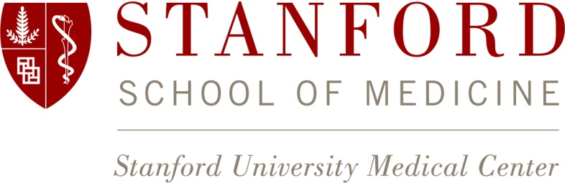

The Departments of Structural Biology and of Molecular & Cellular Physiology at Stanford University School of Medicine have an opening for a full-time, tenure-track faculty position at any rank.

Scientists with a strong record of significant research accomplishments in biological sciences that employ single particle cryo-electron microscopy or cryo-tomography as a major tool are encouraged to apply. Stanford is making a major commitment to expand its scientific resources in this area across all of its schools.

The position’s final faculty rank will be determined by the qualifications and experience of the successful candidate. The predominant criterion for appointment in the University Tenure Line is a major commitment to research and teaching. The individual filling this position will play a major role in the research, teaching and predoctoral training programs of both recruiting departments. The Stanford School of Medicine is committed to maintaining and enhancing the diversity of its professoriate.

Stanford's Departments of Structural Biology and Molecular & Cellular Physiology offer a highly interdisciplinary and collegial environment for basic biomedical research, with state-of-the-art resources and unparalleled opportunities for scientific collaboration. Outstanding expertise in nearly every area of biology, mathematics, physical science, and engineering is present in the Stanford community at large.

Applicants should submit (electronically) their curriculum vitae and a brief (1-2 page) description of research interests and future plans, pdfs of their three most significant publications, and arrange to have three letters of recommendation submitted on their behalf to the Structural Biology/MCP Search Committee c/o Jzesern Tan, at Academic Jobs Online https://academicjobsonline.org/ajo/jobs/5770, Job# 5770. All application materials must be received by October 1, 2015. For more information, please see our websites at http://mcp.stanford.edu/ and http://structuralbio.stanford.edu/.
Stanford University is an equal opportunity employer and is committed to increasing the diversity of its faculty. It welcomes nominations of and applications from women, members of minority groups, protected veterans and individuals with disabilities, as well as from others who would bring additional dimensions to the university’s research, teaching and clinical missions.

